**Subject routeway**

Subject: Maths

Lead: Georgia Patrick

1. Curriculum intent

Our Maths curriculum aims to ensure that every child has an appreciation and love for Maths. We strive for them to become confident mathematicians through problem solving and reasoning. We want our children to be prepared for the wider world to develop numerical fluency to help them gain employment and succeed in their careers. Most of all, we want all children to enjoy Maths, to flourish in this subject and to have an appreciation of the beauty and power of mathematics.

We teach all of our lessons through a mastery approach. Instead of learning mathematical procedures by rote, we want pupils to build a deep conceptual understanding of maths which will enable them to apply their learning in different situations. Each Maths lesson will include the 5 areas of mastery shown below:

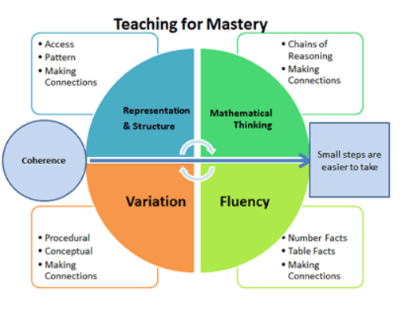

By teaching these 5 areas of mastery, our learners will have a secure understanding of mathematical concepts which will allow them to discuss, explain and justify their mathematical thinking.

We aim to achieve this by teaching them to:

* become fluent in the fundamentals of Mathematics
* reason mathematically
* solve problems by applying their Mathematics

1. Milestones

The *White Rose* scheme clearly sets out expectations and endpoints, in line with National Curriculum expectations for each unit, year group and key stage. There is constant formative assessment and termly summative assessment which feeds into our pupil progress system and informs class planning and intervention. Teachers use a variety of approaches for ongoing formative assessment including low stakes quizzing through STIK (Show That I Know) at the start of each lesson and *White Rose* End of Unit Quizzes. Termly summative assessment is through the *White Rose* End of Term Assessments. Assessment is also supported by termly book looks, pupil voice, and moderation across year groups.

1. Inclusion

Our aim is for all children, including those with SEND, to access the full mathematical curriculum that their peers are accessing. All pupils are entitled to receive high quality teaching from their class teacher. Additional adults are deployed under the supervision of the class teacher to support and scaffold the progress of all children in mathematics. Lessons are carefully planned to facilitate the small steps in learning that will bridge the gap for learners with SEND. Resources, such as dienes, Numicon and counters are effectively used to support the learning of SEND learners alongside pictorial representations and abstract calculations. Scaffolding is also be used to enable children with SEND to access whole class teaching as frequently as possible.

1. Sequencing

Children in our Daycare are taught maths through a bespoke curriculum that focuses on developing mathematical behaviour and language skills. Through song and play, children will start to use counting language, be able to compare amounts and recite numbers to 5. They will also be able to identify shapes, complete some mathematical inset puzzles and squeeze into different space, big and small.

From Nursery to Year 6, we use the *White Rose Maths* approach which is aligned with the Early Years and National Curriculum to build deep understanding, confidence and competency. Our curriculum follows a teaching for mastery approach which systematically builds on previous learning. Each year group starts with a deep focus on number, place value and calculation and goes on to build on that knowledge to support understanding in other areas of mathematics. Review and recall are built in, for example, through the “flash back four” and reinforcement of instant recall facts linked to the current *White Rose* content.

We blend concrete, pictorial and abstract approaches (the CPA method) to give children a firm grasp of numerical concepts and methods. We recognise the importance of mathematical language and support children to articulate and explore their ideas in pairs, groups and the whole class. We encourage regular retrieval practice to ensure strong recall of basic number facts, and teach problem solving to enable children to use and apply their maths knowledge. Our teachers are trained and supported to ensure that no child is left behind and that children with knowledge gaps or specific numeracy issues are supported to access the full curriculum.

Our wider curriculum reinforces mathematical knowledge and maths concepts through, for example, data handling and presentation in ICT, developing sound chronological awareness in History and understanding distances and direction in Geography.

Class Teachers and teaching assistants deliver targeted small group interventions to support children with additional leaning needs in maths. Staff also use same day interventions to address misconceptions immediately. We use data from statutory and non-statutory assessments to identify children needing additional support in maths.

1. Professional development

Our Maths Leader has attended Teaching for Mastery programme through the NCETM Maths Hub. Through this 4-year programme we aim to develop teaching for mastery throughout school. We are currently in the ‘Sustaining’ phase of the process which is the final year. Information from this programme has been disseminated throughout the school

Teachers and TAs have engaged in subject knowledge enhancement courses through the NCETM over the past few years. These members of staff have also received training in how to use concrete resources to support the mathematical understanding of their learners. In recent years, we have also trained our staff in how best to support our SEND learners.

*Version: March 2025*